Internshala Training
INTRODUCTION TO DATA SCIENCE
Internship report submitted in fulfillment of the requirements for the Degree of
B.Tech
in
Computer Science Engineering

Submitted By:
Anshika Bajpai (9917103009)



Department of CS/ IT
Jaypee Institute of Information Technology, Noida
September - 2020

Table of Contents

Page No.
- Declaration 3
- About the company 4
- Certificate 5
- Training Objective 6
- Topics Covered 7
- Final Project Description 8
6.1 Dataset 8
6.2 Data Dictionary 9
6.3 Hypothesis Generation 10
6.4 Model Building 10-11
6.5 Analysis Parameter 11
6.6 Software and Hardware Requirements 11
- Detailed Analysis 12-15
- Result 16
- Conclusion 17
- References 18

Declaration

I Anshika Bajpai, hereby declare that this summer internship report entitled “Predictive Modelling” submitted to Jaypee Institute of Information Technology, Noida for the partial fulfillment of the degree of bachelor of technology is the bonafide record of the work done by me in the due course of my summer internship and the contents and facts prepared and presented by me without any bias and are authentic to the best of my knowledge. I also declare that it has not previously formed the basis of an award for me any degree/ diploma, fellowship or other similar titles of any institute/society.

Name: Anshika Bajpai
Enrollment: 9917103009

About the company



Internshala is a technology company on a mission to equip students with relevant skills & practical exposure through internships and online trainings. A platform where people can discover their passion and turn it into their career.
Internshala is an internship and online training platform, based in Gurgaon, India.The company is founded by Sarvesh Agrawal, an IIT Madras alumnus, in 2010, the website helps students find internships with organisations in India. It started out as a WordPress blog that aggregated internships across India and articles on education, technology and skill gap. Internshala launched its online training in 2014. As of 2018, the platform had 3.5 million students and 80,000 companies.
The training was conducted by Analytics Vidhya which is one of the leading data science communities in India. The beginner-friendly nature of the training helped me stay on track. The instructors taught with great attention to detail and any doubts that I had were cleared on a forum. There was also an option to send our queries directly to the instructor who would answer them promptly. This fostered a great student-teacher relationship even though it was an online interaction.

Certificate

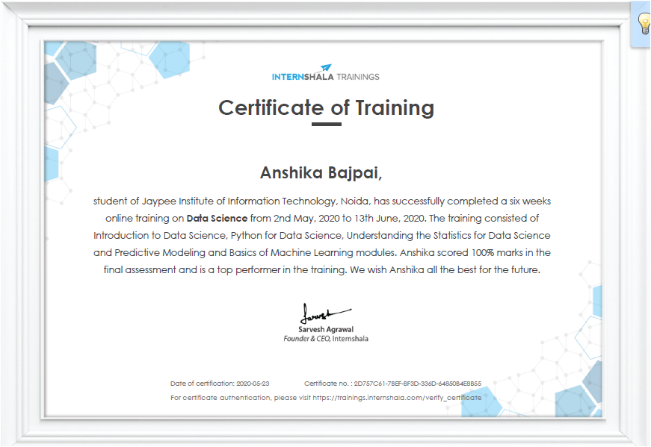

Training Objective

The objective of the training was to learn the basics of python, statistics, predictive modeling, and basics of machine learning with the help of video tutorials and assignments, assessments tests, quizzes, and practice exercises to get a hands-on learning experience.
The main objective was to build a predictive model which will help solve real-life problems and make human-life easier.

Topics Covered
The training consisted of Introduction to Data Science, Python for Data Science, Understanding the Statistics for Data Science and Predictive Modeling and Basics of Machine Learning modules. Apart from final test and project, an assessment test was conducted after every module. And passing this test was necessary in order to move towards next module.

- Introduction to Data Science
Got an overview of data science along with the basic terminologies used in this field such as MIS, Detective Analysis, business intelligence, Big Data. Understood its different applications and insights on how data science disrupts industries.

- Python for Data Science
Learned the basics of python - how to read a CSV file, operators, variables, lists, dictionaries, functions, extensive packages used and data structure in data science.

- Understanding the statistics for Data Science
Learned about the measures of central tendency (mean, median, mode, variables, variance, standard deviation), data distribution, probability, data statistics and types of testing. Understood the concepts of Descriptive and Inferential statistics.

- Predictive Modeling
Learned about predictive models & their stages, data extraction & exploration, univariate & bivariate analysis, model building, linear and logistic regression, Decision Tree and K-means.

Final Project Description

Term deposits are a major source of income for a bank. It is a cash investment held at a financial institution. Money is invested by clients for an agreed rate of interest over a fixed amount of time, or term. The bank has various outreach plans to sell term deposits to their customers such as email marketing, advertisements, telephonic marketing and digital marketing.
Telephonic marketing campaigns still remain one of the most effective way
to reach out to people. However, they require huge investment as large call
centers are hired to actually execute these campaigns. Hence, it is crucial
to identify the customers most likely to convert beforehand so that they can
be specifically targeted via call.
The main task is to predict if the client will subscribe to term deposit with the help of client data such as age of the client, their job type, their marital status,the duration of the call, day and month of the call etc.

6.1 Dataset

Dataset was already provided by Internshala:

- train.csv : Use this dataset to train the model. This file contains all the
client and call details as well as the target variable “subscribed”. You have to train your model using this file.
- test.csv : Use the trained model to predict whether a new set of clients
will subscribe to the term deposit.

6.2 Data Dictionary
VARIABLE | DEFINITION
ID | Unique client ID
age | Age of the client
job | Type of job
marital | Marital status of the client
default | Credit in default.
previous | number of contacts performed before this campaign
poutcome | outcome of the previous marketing campaign
education | Education level
housing | Housing loan
loan | Personal loan
day_of_week | Day of week of contact
duration | Contact duration
campaign | number of contacts performed during this campaign to the client
month | Contact month
contact | Type of communication
pdays | number of days that passed by after the client was last contacted
Subscribed (target) | has the client subscribed a term deposit?

6.3 Hypothesis Generation

These can a possible set of hypothesis:

Customers with higher balance in default, loans (personal and housing) are more likely to not subscribe to term deposit.
Customers with success in poutcome with higher data in previous and lesser data in pdays variable are more likely to subscribe to term deposit.
Customers with better jobs resulting in higher balance are more likely to subscribe.

At this stage, any of these hypotheses would be true. For now these will be working as possible assertions in order to achieve the desired outcome.

6.4 Model Building
This section defines some common classification techniques that will be used in the project for model building.

- Decision Trees
Decision trees are one of the most popular learning tools in data mining. They are very popular because they generate an easy-to-interpret model, which reveals the most relevant features. The model generated is a tree structure in which each internal node represents a “test” on a particular feature. The test outcomes split records in subsets, which create new nodes in the tree structure.
Once a particular criteria is reached, a node stops splitting itself and becomes a leaf. A leaf is often labeled with the majority class, that is, the most frequent class in the leaf. Each path from the root to a leaf describes a rule. A record which satisfies all the conditions of one rule is labeled with the relative leaf label. This learning algorithm is powerful, because it can catch non-linear relationships between features, maintaining representation simplicity.
Moreover, it is optimized to deal with a big amount of data and with missing values. Unfortunately, a decision tree classifier is unstable: a small change in the data can heavily modify the tree structure and the relationships generated, hence the computational time can vary a lot and sometimes this could be inefficient. The instability makes decision trees prone to over- fitting, although there exist some techniques to avoid it. In particular, random forest leverages this very instability to create a more stable and accurate model, as explained in subsection further.

- Logistic Regression
The logistic regression is a classification model and it was developed in order to extend the linear regression model which is, instead, a regression model (i.e. the outcome is continuous). Although linear regression can be adapted for the classification task, it gives poor results. Therefore, researchers have developed the logistic regression model to study the relationships between a binary outcome (0 or 1) and features.

6.5 Analysis Parameter
Accuracy_score is a performance measurement categorised under Evaluation Metrics and is explained as the ratio of number of correct predictions to the total number of input samples.

Accuracy = Number of Correct Predictions
Total Number of predictions made

In this project, the evaluation metrics was decided to be accuracy because it provides best results When there are equal number of samples belonging to each class.

6.6 Software and Hardware Requirements

- Hardware Requirements
  - Processor Required: Intel Core i3 and above.
  - RAM Required: 4 GB and above
- Software Requirements
  - 1.Operating System like Windows (64- bit), Mac, Linux
  - 2.Anaconda Navigator
  - 3.Python 3 and above

Detailed Analysis

By Univariate Analysis
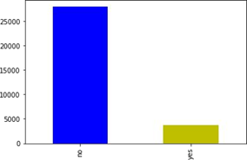

Fig5.1: Bar plot of subscribed variable of train data set
Above shows the bar plot of subscribed people in train data set, i.e. 3715 users out of total 31647 have subscribed which is around 12% where x-axis shows whether subscribed or not and y-axis shows no.of people.
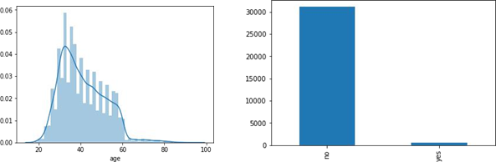
Fig5.2: Distribution of age variable. Fig5.3: Frequency table of default history of clients.

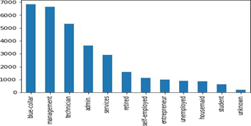

Fig5.4:Frequency table for different jobs of clients.

After looking at all these relationships we inferred that most of the clients fall in the age-group between 20-40, most of the clients belong to blue collar jobs and students are least in number and 90% of the clients have no default history.

Bi-Variate Analysis
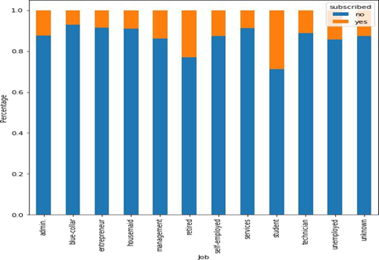

Fig5.5: Relationship between different jobs and target variable
From the above graph we can infer that students and retired people have higher chances of subscribing to a term deposit, which is surprising as students generally do not subscribe to a term deposit.

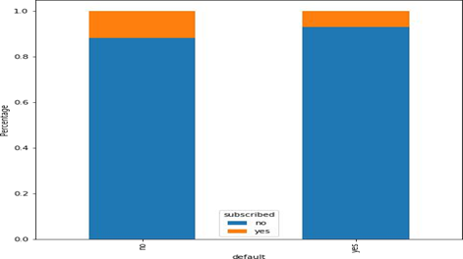
Fig5.6: Relationship between default history and target variable.
Above graph shows that clients having no previous default have slightly higher chances of subscribing to a term loan as compared to the clients who have previous default history.
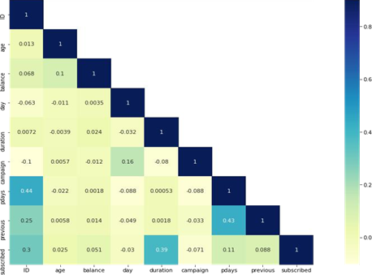

Fig5.7: Correlation between duration of the call with the target variable.

Results
- After following the complete process of predictive modelling through problem definition, hypothesis generations, data extraction and exploration and lastly model building. The result of predictions through accuracy_score was 90.42% for train data set
- After getting the results for train data set in order to make the prediction on test data set. We made the similar changes in the test set as we have done in the training set before making the predictions. And the results of through accuracy_score was 90.88%.

Conclusion

After the getting the desired results of predictive modelling, it can be concluded that the hypothesis generated earlier were almost correct. As after processing the data we got to know that:
- Clients having no previous default have slightly higher chances of subscribing to a term loan as compared to the clients who have previous default history.
- Duration of the call is highly correlated with the target variable. This can be verified as well. As the duration of the call is more, there are higher chances that the client is showing interest in the term deposit and hence there are higher chances that the client will subscribe to term deposit.
- Students and retired people have higher chances of subscribing to a term deposit, which is surprising as students generally do not subscribe to a term deposit. The possible reason is that the number of students in the data set is less and comparatively to other job types, more students have subscribed to a term deposit.

References

[1] P.Nilima Patil, P.Rekha Lathi, and P.Vidya Chitre, “Comparison of c5.0 and cart classification algorithms using pruning technique”, 2014.
[2] D.Hand, H.Ader, and G.Mellenbergh, “Advising on research methods: A consultant’s companion”, 2008.

